**Networking Notes – 2**

Network Devices: We understand what networking is and what are the different types of media used to connect devices. But for a network to exist and work properly, we need several hardware devices that perform distinct functions.

**Definition:** Network devices are physical devices that enable communication and interaction between hardware on a computer network.

Various Networking devices are used to establish and use connections between several devices and also within the computers. Some of these devices are:

1. Modem: Modem is a device that enables a computer to send or receive data over telephone or cable lines.

As the data that your computer transmits is digital and telephone lines can only transmit analog data, the modem is used to convert these digital signals into analog signals and vice versa if necessary.

It is a combination of two devices:

1. Modulator: Converts digital data into analog data.
2. Demodulator: Converts analog data into digital data signals.

There are three basic types of Modems:

1. Simplex: It can transfer data in only one direction.
2. Half Duplex: It can transfer data in both directions but only one at a time.
3. Full Duplex: It can transfer data in both directions simultaneously.

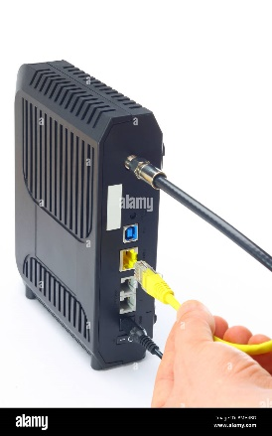

1. RJ45 Connector: RJ45 is the acronym for Registered Jack 45. RJ45 connector is an 8-pin jack used by devices to physically connect to Ethernet based local area networks (LANs). The cable used for Ethernet LANs are twisted pair ones and have RJ45 connector pins at both ends. These pins go into the corresponding socket on devices and connect the device to the network.

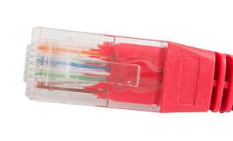

1. Ethernet Card: More popularly known as Network Interface Card(NIC) is a hardware component used by computers to connect to Ethernet LAN and communicate with other devices on the LAN. Your computer has a NIC card built into it and might have a RJ45 connection port too. Most NIC cards in modern computers can also interface with wifi and Bluetooth enabled Internet connection.

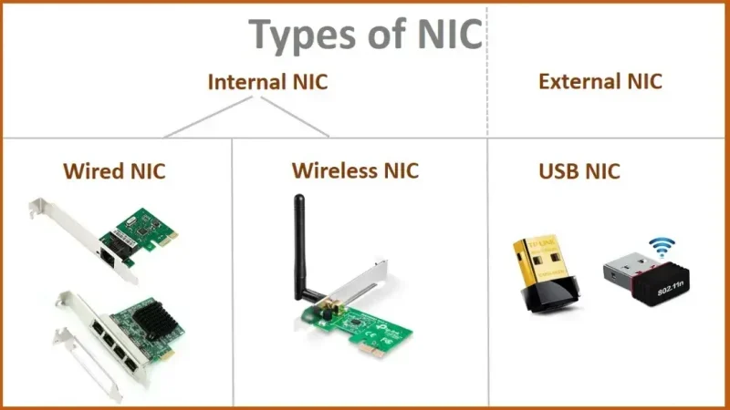

1. Wi-Fi Card: Wi-Fi is the acronym for wireless fidelity. Wi-Fi technology is used to achieve wireless connection to any network. Wi-Fi card is a card used to connect any device to the local network wirelessly. The physical area of the network which provides internet access through Wi-Fi is called Wi-Fi hotspot. Hotspots can be set up at home, office or any public space. Hotspots themselves are connected to the network through wires.